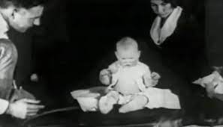Case Study: Little Albert (Watson and Rayner 1920)

Sample Group:

Methodology/Procedure:

Results/findings:

Contributions to psychology/society:

Strengths:

Limitations: